Project Documentation: Berkay Topal
Deliverable 1
Project Idea: Brick Breaker / Arcade Game
Title of Game: Brick Blitz

Brief Justification of Project Idea:
- Brick breaker is a game that everyone overlooks on how easy it is, but the mechanics behind it, I believe, is very complex, and has a lot of room for scalability.
  - Hence want to prove that it is by making the game

- The idea offers good balance of challenge and feasibility, where it is a project that I can get done comfortably by the due date.

- It is an idea easily scalable, where I can keep adding more and more ideas to it as I go on, it is not limited.

- Finally, it offers the understanding of complex topics such as collision detection and physics-based movement, further expanding my knowledge.

Problem Definition:
- Problem: Many arcade-style games provide quick, engaging gameplay, but lack the modern implementations that improve the user experience, and the ability for students & developers to learn complex and simple gameplay mechanics

- Idea: Hence, with Brick Blitz I plan to develop a fun, interactive Brick Breaker game that challenges players’ reflexes, allows students and developers to learn simple and complex gameplay mechanics, and overall provide a rewarding experience

Target Audience:
- Casual gamers who enjoy classic arcade-style games

- Students and developers interested in learning about game development, particularly collision detection, physics-based movement, and event handling in Pygame

- Game controls are simple and easy, so users of all ages allowed to play, but mainly targeting younger generation who more commonly play games

Objectives:
Main Objectives:
- Develop a fully playable Brick Breaker game, with core mechanics (Eg. Ball movement, paddle control, brick-breaking, etc.), and side mechanics (Eg. Menu, Sound, Directional Control, Levels, etc.) that is better than Arkanoid.

Sub-Objectives:
- Implement collision detection between ball, paddle, bricks

- Design progressive difficulty, where it has multiple levels with increasing challenges

- Make power-ups & other mechanics to enhance gameplay

- Ensure smooth performance, efficient use of memory, and user-friendly control

- Make clear and aesthetic “Game Over” and “Win” conditions/screens, with menus and such allowing players to start / restart the game

Initial Design of Program (Different Screens):
Start Screen:
- Will start game with main menu, has:
  - Title, “Start Game” button, “Instructions” button, “Volume” button, “Quit” button

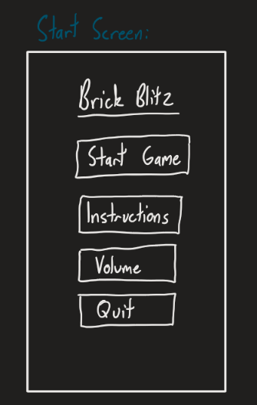

Game Screen:
- Has paddle, ball, bricks

- Scoring system

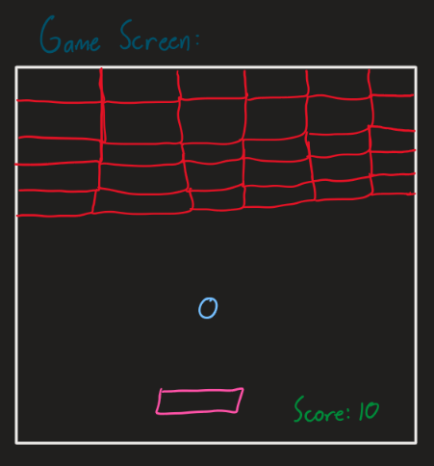

Game Over Screen:
- Has game over message, final score and “Main Menu” button

